**Marmon Weekly BVC**

(My) Order of Tabs for Sheet:

1. UTC Main
2. UTC FS
3. Transco
4. Procor
5. UTXLA
6. Mckenzie
7. Penn Machine
8. Railserve Inc + Railserve Mechanical
9. Trackmobile + Trackmobile Parts Group
10. Marmon RR
11. BVC

Steps:

1. Go to: https://www.dalkoinctms.com/#/carrier-selection-report
2. Choose Carrier Selection Report, Type: Basic, Run By: Invoice Date, Download.
3. Run Previous Week. (M-F)
4. Repeat process for each client.
5. Format Column Width: 8.75, Row Height: 40.
6. Delete extra blank rows and columns.
7. Potential Savings Cases:
   1. If PS is negative, copy-paste SL into LCC and zero PS.
   2. If PS is positive and same carrier, copy-paste SL into LCC and zero PS.
8. Auto-sum PS and Total Costs of SC.

Special Steps for UTC Main, UTC FS, and Transco:

* Custom sort all by Destination City.
* Check the cities in both Destination City and Origin city for Evanston/Green River/Miles City.
* UTC Main – Evanston
* UTC FS – Green River
* Transco – Miles City
* Copy-paste the city to the columns on the right of the table.
* After passing the PS cases, copy-paste the PS into the column beside it.
* Then zero out the PS in the table for those cities.

1. Example (UTC FS):

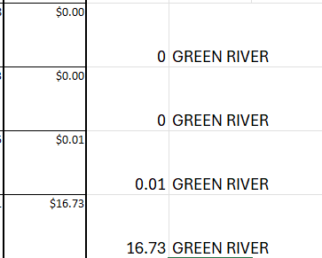

Special Notes and Tips:  
1. Look out for Smartway/DRI Worldwide/Dalko Defender Insurance in the Carriers (Particularly in Trackmobile). If a SC or LCC has it AND the same Carrier, copy-paste SC into LCC and zero PS.

2. I usually do UTC Main, UTC FS and Transco last.

3. Can drag a 0 down to copy it to more columns.

4. Could reuse a BVC table from previous week so you can keep format. Just update the numbers.

PROTIPS:

1. You can shift-select all tabs in the Marmon weekly and format them all at once.
   1. i.e. width, height, fill-color(white), deleting blank columns (like rows 3, 5, 7, 10, 31-37, 60-66, 89-95, 118-124, columns w-y)
2. For the BVC tab, you can ctrl-select after =, the TC – PS for OPT and PS for NON.
3. Alt+= is the shortcut for auto-sum.
4. In the BVC table, you can press =, go to the sheet for the Total PS, click on PS and enter.
5. In the BVC table, you can press =, go to the sheet for the Total Cost and Total PS, click on Total Cost #, press minus, Total PS #, enter.